**SENIOR YEAR – IMPORTANT INFORMATION**

**See your Counselor**: Counselors will meet with seniors on an as needed basis. It is your responsibility to make an appointment with your counselor to discuss the graduation requirements and the college application process. Unless you already have a relationship with another counselor, you must see your assigned counselor for college applications, transcripts, graduation requirements, etc.

**Graduation Requirements:** Please review your academic history to make sure that you are on track to graduate and all grades are accurate. You will receive a Senior Letter in the Fall, which will show your progress towards graduation. It will be mailed to the address on file in Skyward. If you know that you are credit deficient, GPA deficient or missing required courses, please see your counselor IMMEDIATELY to learn about credit retrieval options.

**College Representatives**: Please be on the lookout for announcements regarding college representatives visiting EHS throughout the fall semester. Sign up to meet with them on the Student Services Overview page of the EHS website.

**Waivers**: ACT and SAT waivers are available in the counseling office for those students who qualify for free or reduced lunch or have other financial obstacles meeting eligibility criteria. For SAT, once you use one physical waiver, your second waiver will be digital and already a part of your College Board account. For CLT waivers, you can apply at https://www.cltexam.com/testing-accommodations/ College Application waivers are available in Guidance to students that have taken standardized tests with a waiver. Transcript fee may be waived; see your Counselor if you have financial need.

**College Applications**: Start your applications as soon as possible, as November 1 is a common deadline. All ACT and SAT testing should be done by December to be included in the college decision-making process. However, you can continue to test to become eligible for scholarships such as Bright Futures (until August 31), or to appeal a deferred decision.

**The Application Process**

* Complete student portion of the application
* Write essay
* Update Resume
* Complete SSAR and supplements if required.
* Request letters of recommendation - The more information we have about you and time we have to write, the more in-depth your recommendation will be.

**From teachers** – Ask early and give as much information to your teacher if possible, such as deadlines, how and where to send recommendation, etc. Request the letter at least 2 weeks before the deadline.

**From counselor** – Ask as early as possible. You may not need a letter from your counselor at all; follow recommendation guidelines for each school

Complete the following forms and submit to counselor at least 2 weeks before recommendation letter deadline: Resume, Parent Insight Form, Senior Student Data Form

* **Resume** – a formal resume is preferred, but a list of extracurricular interests and activities will be accepted.
* **Request Transcripts** Complete Transcript Request Form and submit to Mrs. Haywood in guidance for any schools that are NOT on Common App or Coalition. Submit transcript fees – FREE for electronic transcript submission to State University colleges and universities; $5.00 to private or out of state colleges and universities Transcripts requests must be submitted at least one week before the application deadline. FINAL transcript requests will be handled through senior English classes.
* Check that the school has received all documents – It is your responsibility to follow up with each school to see if your application is complete. **ALL FORMS ARE AVAILABLE ON EHS WEBSITE>Student Services>College Readiness Files** **If you are applying through Common Application, you must invite your Counselor and teachers. Transcripts and Letters of Recommendation will be submitted through the Common App portal.

**Scholarship & Financial Aid Information**:

* **Eastside website:** Visit Student Services>College Planning>Scholarship Information. Click on “local scholarships” tab to view scholarships and click on each link for more information.
* **Bright Futures Scholarship:** You must apply for the Bright Futures Scholarship in the Fall of your senior year, through the Florida Financial Aid Application. It is available **October 1.**
  + Counselors will be taking all seniors to the computer lab to apply for Bright Futures, as well as other Florida scholarships. https://www.floridastudentfinancialaidsg.org/
* **FAFSA: T**he Free Application for Federal Student Aid will be available December 1, 2024. You can apply online at www.fafsa.ed.gov for all federal financial aid. Counselors will hold at least one Financial Aid Night at EHS to assist you and your parents with completion of the FAFSA. Know your Counselor First Letter of Student’s Last Name Counselor

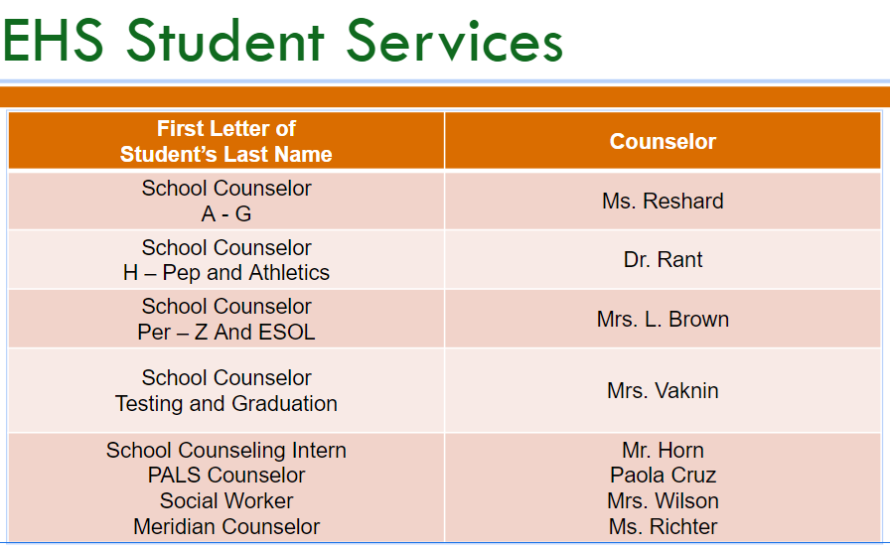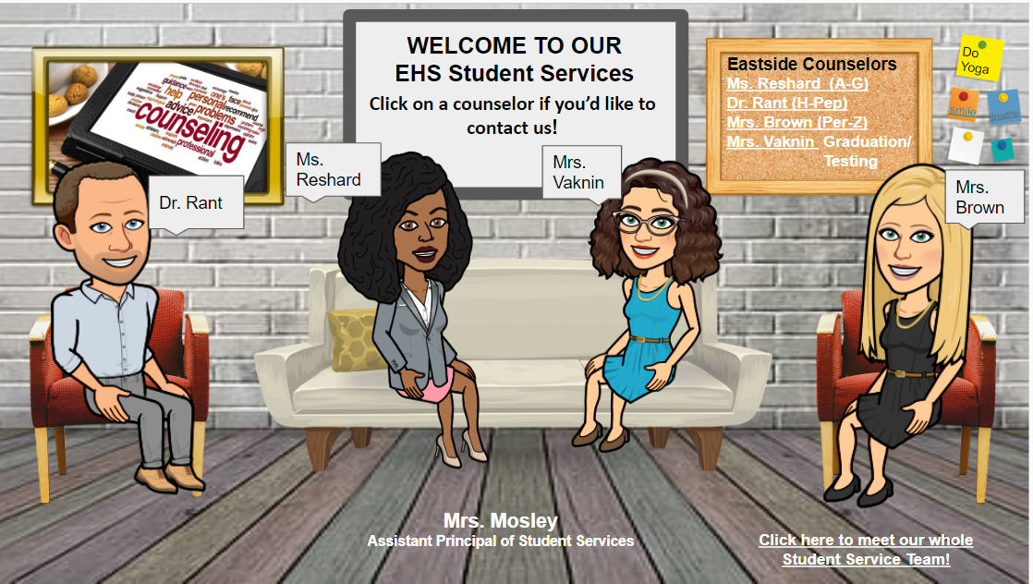

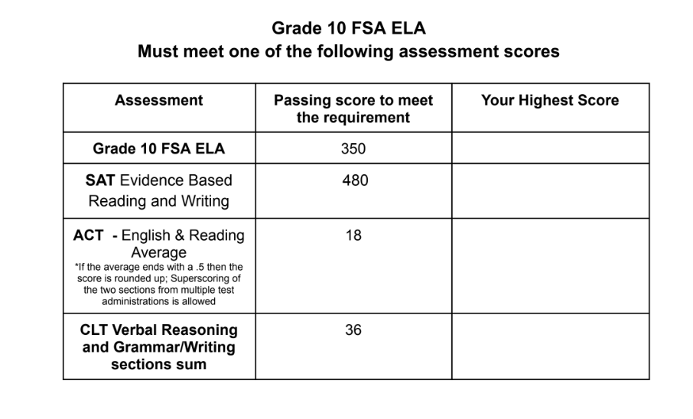

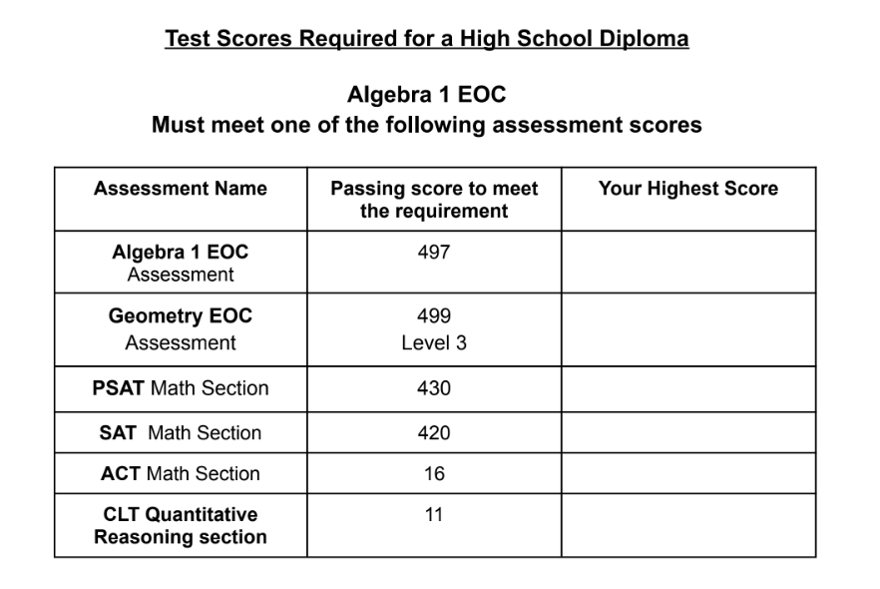

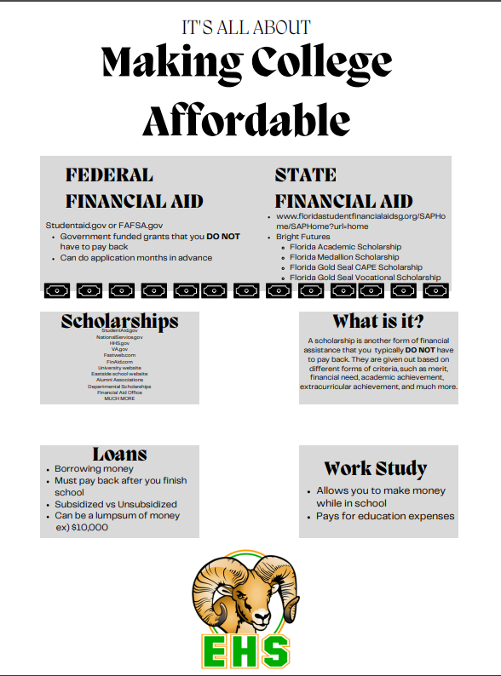

**FINANCIAL AID CHECKLIST**

* **Apply for state financial aid**
  + Submit the Florida Financial Aid Application (FFAA) (Florida Bright Futures is INCLUDED)
    - [www.floridastudentfinancialaidsg.org](https://r.search.yahoo.com/_ylt=AwrFFHaV_v9mCj0DoxNXNyoA;_ylu=Y29sbwNiZjEEcG9zAzEEdnRpZAMEc2VjA3Ny/RV=2/RE=1729262485/RO=10/RU=https%3a%2f%2fwww.floridastudentfinancialaidsg.org%2f/RK=2/RS=wXt3hCYrn0xFbaB2huPxChb3Bps-)
    - Available Oct 1, 2024
    - Username: _________________________ Password: _______________
    - Date Submitted: _____________
* **Apply for federal financial aid**
  + Submit the Free Application for Federal Student Aid (FAFSA)
    - https://studentaid.gov/h/apply-for-aid/fafsa
    - Available on or before Dec 1, 2024
    - Steps:
      * Create Student Federal Student Aid Account (FSA ID/electronic signature for FAFSA)
        + https://studentaid.gov/fsa-id/create-account/launch
        + Username: _____________ Password: _______________
      * Create Parent Federal Student Aid Account (FSA ID/electronic signature for FAFSA)
        + https://studentaid.gov/fsa-id/create-account/launch
        + Username: _____________ Password: _______________
        + *Your parent may already have an account from their own financial aid or a sibling’s financial aid.
      * Student must complete the student portion of the FAFSA
      * Parent must complete the parent portion of the FAFSA
    - Date Submitted: _____________ *FAFSA HELP NIGHTS - 1/14 and 3/25

*Some universities may also require you to complete other financial aid forms, such as the CSS Profile.

* **Apply for scholarships**
  + Alachua County Education Foundation Senior Scholarships
    - <https://edfoundationac.org/senior-scholarships/>
    - Available Dec 1, 2024
    - Single application for multiple scholarships; can be used anywhere
  + Santa Fe General Scholarships
    - <https://www.sfcollege.edu/fa/scholarships/college-scholarships.html>
    - Available in Spring semester - Date TBD
    - Single application for multiple scholarships; can only be used at SFC
    - Needs-based scholarships AND Merit-based scholarships available
    - Must complete SFC application BEFORE applying for scholarships
  + Santa Fe Foundation Scholarships
    - <https://www.sfcollege.edu/foundation/scholarships/>
    - Available in Spring semester - Date TBD
    - Single application for multiple scholarships; can only be used at SFC
    - Needs-based scholarships AND Merit-based scholarships available
    - Must complete SFC application BEFORE applying for scholarships.

**SAMPLE RESUME**

**Jane Doe**

1234 East Side High BLVD Gainesville, FL 32601

(555) 555-5555 - [jane.doe@gmail.com](mailto:jane.doe@gmail.com)

**EDUCATION**

* Santa Fe College, Gainesville, FL (3.5 GPA)
  + May 2021 – Present
* Eastside High School, Gainesville, FL, class of 2023 (3.6 GPA and 4.00 HPA)
  + August 2019 – Present

**EXPERIENCE**

* Publix - June 2021 - present
  + Cashier
    - Effectively handle cash
    - Assist customers with purchasing items

**INVOLVEMENT**

* National Honor Society - April 2020 - Present
  + Participated in a lot of community service activities such as the Gainesville clean up and Class of 2022 Graduation and Senior Night.
* Florida Future Educators of America (FFEA) - *Mentor -* August 2019 - May 2022
  + Read books to little kids at Stephen Foster Elementary School
* Book Club - August 2022 – Present
  + Secretary (2017-2018)
    - Organized minutes for each meeting held
    - Analyzed who attended the meetings
* Health Occupations Students of America (HOSA) - August 2019 – Present
  + Competed against students from other schools in the region in a series of health-care related events.
  + Secretary (2017-2018)
    - Organized minutes for each meeting held
    - Analyzed who attended the meetings

**AWARDS**

* Honor Roll – (2019 – Present)
* Academic Award for Tennis - 2020
* 2nd Place Medical Assisting - Health Occupations Students of America (HOSA) - 2020
* NHA Certified Medical Administrative Assistant (CMAA) – 2019

**SKILLS**

* Microsoft Office (Word and PowerPoint)
* Language- (Mandarin and English - Fluent Speaker)

**REFERENCES**

* John Doe - [john.doe@gmail.com](mailto:john.doe@gmail.com)
  + 555-111-5345

**Common Application College Prompts**

1. Some students have a background, identity, interest, or talent that is so meaningful they believe their application would be incomplete without it. If this sounds like you, then please share your story.
2. The lessons we take from obstacles we encounter can be fundamental to later success. Recount a time when you faced a challenge, setback, or failure. How did it affect you, and what did you learn from the experience?
3. Reflect on a time when you questioned or challenged a belief or idea. What prompted your thinking? What was the outcome?
4. Reflect on something that someone has done for you that has made you happy or thankful in a surprising way. How has this gratitude affected or motivated you?
5. Discuss an accomplishment, event, or realization that sparked a period of personal growth and a new understanding of yourself or others.
6. Describe a topic, idea, or concept you find so engaging that it makes you lose track of time. Why does it captivate you? What or who do you turn to when you want to learn more?
7. Share an essay on any topic of your choice. It can be one you've already written, one that responds to a different prompt, or one of your own design.

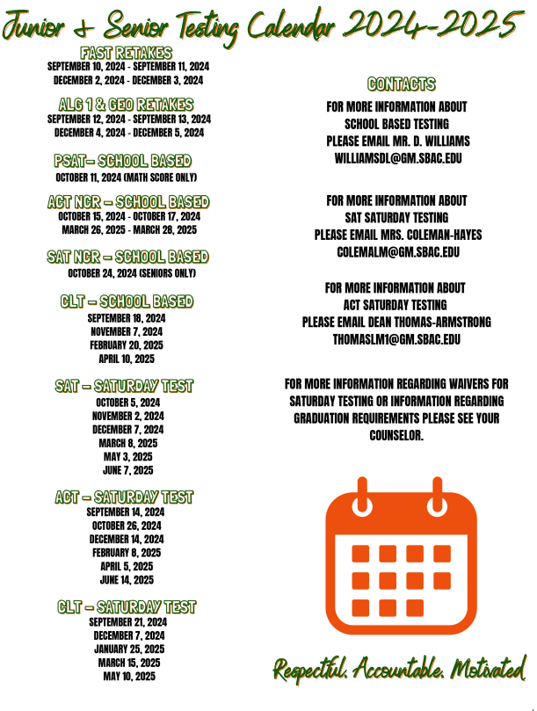

**Test Dates**

**ACT**

| **Test Date** | **Regular Registration Deadline** | **Late Registration Deadline** |
| --- | --- | --- |
| September 14, 2024 | August 9 | August 25 |
| October 26, 2024 | September 20 | October 7 |
| December 14, 2024 | November 8 | November 22 |
| February 8, 2025 | January 3 | January 20 |
| April 5, 2025 | Feb 28 | March 16 |
| June 14, 2025 | May 9 | May 26 |
| July 12, 2025 | June 6 | June 20 |

**SAT**

| **Test Date** | **Registration Deadline** | **Deadline for changes, regular cancellation, and late registration** |
| --- | --- | --- |
| August 24, 2024 | Aug 9 | Aug 13 |
| October 5, 2024 | Sept 20 | Sept 24 |
| November 2, 2024 | Oct 18 | Oct 22 |
| December 7, 2024 | Nov 22 | Nov 26 |
| March 8, 2025 | Feb 21 | Feb 25 |
| May 3, 2025 | April 18 | April 22 |
| June 7, 2025 | May 22 | May 27 |

* **ACT and SAT waivers are available in Guidance for those students who qualify for free or reduced lunch or have other financial obstacles**
* **Those eligible can receive two of each waiver:**
  + **SAT - once you use physical waiver, your second waiver will be digital and already on your College Board account**

